|  |  |  |  |  |
| --- | --- | --- | --- | --- |
| PI | RPI01 | RPI02 | RPI03 | RPI04 |
| TYPE | 3 | 3 | 3 | 3 B+ |
| install fresh Raspian OS  *raspberry imager.exe: raspberry pi OS full version* | done | done | Done | ☺ |
| Change pi password with: sudo raspi_config to rasp## | rasp01 | rasp02 | rasp03 | rasp04 |
| Change pi hostname with: sudo raspi_config | RPI01 | RPI02 | RPI03 | RPI04 |
| Set fixed IP address | 192.168.2.45 | 192.168.2.47 | 192.168.2.48 | 192.168.2.46 |
| Enable ssh with: sudo raspi_config | Done | Done |  | ☺ |
| Set locale with: sudo raspi_config *US en UTF-8* | done | Done |  | ☺ |
| Set time zone with: sudo raspi_config *EU en AMS* | done | Done |  | ☺ |
| Disable wifi and Bluetooth: *Sudo nano /boot/config.txt*  Add to end of file  *# disable wifi and Bluetooth*  *# ANF 11-6-2020*  *dtoverlay=disable-wifi*  *dtoverlay=disable-bt* | Done | Done |  | ☺ |
| Set static ip address on pi  NOTE: when router changes change address in dhcpcd.conf  From: pimylifeup.com   1. find address current router: ip r | grep default first ip address in output is router address( = ROUTERIP) 2. find current DNS server: sudo nano /etc/resolv.conf ip address after nameserver is DNS nameserver (= DNSIP) 3. modify dhcpcd.conf: sudo nano /etc/dhcpcd.conf 4. add or change lines to look like (examples in file are provided as comments starting with #) 5. NETWORK = eth0 6. STATICIP = 192.168.2.166 or .160 .162 .164   interface <NETWORK>  static ip_address=<STATICIP>/24  static routers=<ROUTERIP>  static domain_name_servers=<DNSIP>   1. Save with ^O 2. Exit with ^X 3. Restart with sudo reboot 4. Check with hostname -I should show static ip address | done | done |  | done |
| Reposition menubar : Menu->Prererences->appearance settings->Menu Bar | done | done |  | ☺ |
| Create user fa; *sudo adduser fa* | done | done |  | ☺ |
| Set password to: rasp## with sudo passwd fa | rasp01 | rasp02 | rasp03 | rasp04 |
| Make fa lid van su:  *sudo usermod -a -G* *adm,dialout,cdrom,sudo,audio,video,plugdev,games,users,input,netdev,gpio,i2c,spi fa* | Done | done |  | ☺ |
| check by temp changing to fa: *sudo su fa*  return with: *exit* | Done | done |  | ☺ |
| Install dotnetcore sdk: create folders and path  *sudo mkdir -p /opt/dotnet*  *sudo tar zxf Downloads/dotnet-sdk-3.1.101-linux-arm.tar.gz -C /opt/dotnet*  make available to all users  sudo ln -s /opt/dotnet/dotnet /usr/local/bin  get .NET core sdk 3.1.3 from:  <https://download.visualstudio.microsoft.com/download/pr/dbf4ea18-70bf-4b0f-ae9c-65c8c88bcadd/115e84fb95170ddeeaf9bdb9222c964d/dotnet-sdk-3.1.301-linux-arm.tar.gz>  # dit klopt niet  install with  *tar zxf dotnet-sdk-3.1.301-linux-arm.tar.gz -C $HOME/dotnet*  check install with:  *cd dotnet && tree*  *dotnet --info* | done | done |  | ☺  ☺  ☺  ☺ |
| Set path for user pi( and possibly fa)  set path and env edit: *sudo nano ~/,bashrc*  add to end off file  *export PATH=$PATH:/opt/dotnet*  *export DOTNET_ROOT=$HOME/dotnet* | Done | done |  | ☺ |
| Install visual studio code from  <https://code.visualstudio.com/docs/setup/raspberry-pi>  *sudo apt update*  *sudo apt install code* | Done | done |  | ☺ |
| *updating goes with:*  *sudo apt update*  *sudo apt upgrade code* | done | done |  | done |
| *Turn off sleeping wlan0: sudo iw wlan0 set power_save off* | done |  |  | done |

NOTE: IP range 192.168.2.160 tot 198 set in router

d

## Add subdomain to localhost URL

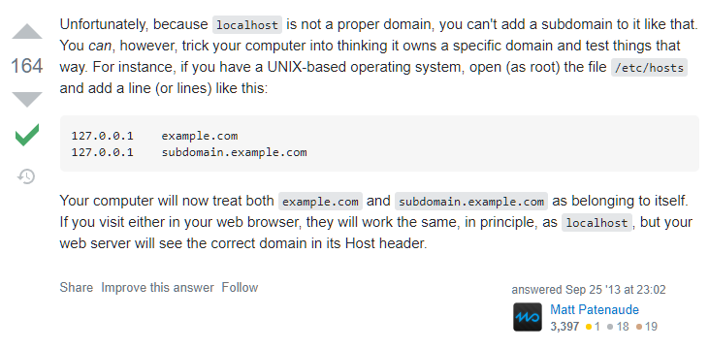

Config /var/www for upload

<https://superuser.com/questions/19318/how-can-i-give-write-access-of-a-folder-to-all-users-in-linux>

install public ssh key on pi

<https://www.chrisjhart.com/Windows-10-ssh-copy-id/>

sus

